VLSI INTERNSHIP – TASK 1 REPORT

Introduction to VLSI Design Flow and Basic Digital Logic Implementation

Submitted By
Name: Sharvesh S
Register Number: 513123106096
College: Thanthai Periyar Government Institute of Technology
Department: Electronics and Communication Engineering

1. Objective
To study the VLSI Design Flow, understand the operation of basic logic gates, simulate the gates using Logisim Evolution, and verify their outputs using truth tables.

2. Introduction
VLSI (Very Large Scale Integration) is the process of integrating millions of transistors onto a single semiconductor chip. VLSI technology is used in modern electronic devices such as processors, memory chips, mobile phones, and embedded systems.
Digital logic forms the foundation of VLSI design. Logic gates perform basic logical operations and are used to build complex digital circuits.

3. VLSI Design Flow
The VLSI Design Flow is a systematic process used to design and manufacture integrated circuits.

3.1 System Specification
The functionality, performance, power consumption, and design requirements of the chip are defined.

3.2 Architecture Design
The system is divided into functional blocks and the overall structure of the chip is planned.

3.3 RTL Design
The circuit behavior is described using Hardware Description Languages such as Verilog or VHDL.

3.4 Functional Verification
The RTL design is tested to ensure that it performs the intended functionality correctly.

3.5 Logic Synthesis
The RTL code is converted into a gate-level netlist consisting of logic gates and flip-flops.

3.6 Physical Design
The gate-level netlist is converted into a physical layout through placement and routing.

3.7 Physical Verification
The layout is checked using Design Rule Check (DRC) and Layout Versus Schematic (LVS).

3.8 Fabrication
The verified design is manufactured on silicon wafers.

3.9 Testing and Packaging
The fabricated chips are tested, packaged, and prepared for deployment.

VLSI Design Flow Diagram
System Specification
↓
Architecture Design
↓
RTL Design
↓
Functional Verification
↓
Logic Synthesis
↓
Physical Design
↓
Physical Verification
↓
Fabrication
↓
Testing & Packaging

4. Logic Gates
Logic gates are the fundamental building blocks of digital circuits.

4.1 AND Gate

Theory
The AND gate produces a HIGH output only when all inputs are HIGH.

Truth Table
A | B | Y
0 | 0 | 0
0 | 1 | 0
1 | 0 | 0
1 | 1 | 1

Simulation Result
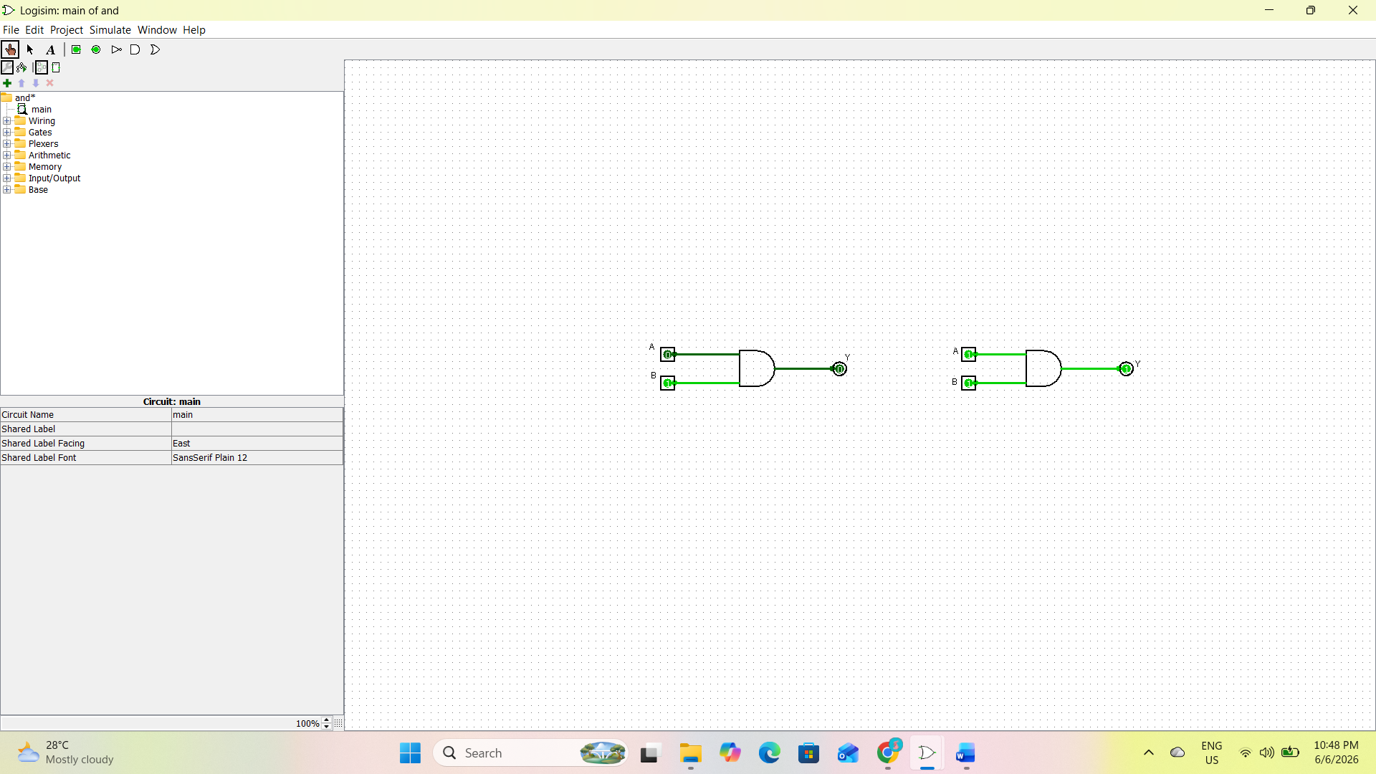

4.2 OR Gate

Theory
The OR gate produces a HIGH output when at least one input is HIGH.

Truth Table
A | B | Y
0 | 0 | 0
0 | 1 | 1
1 | 0 | 1
1 | 1 | 1

Simulation Result
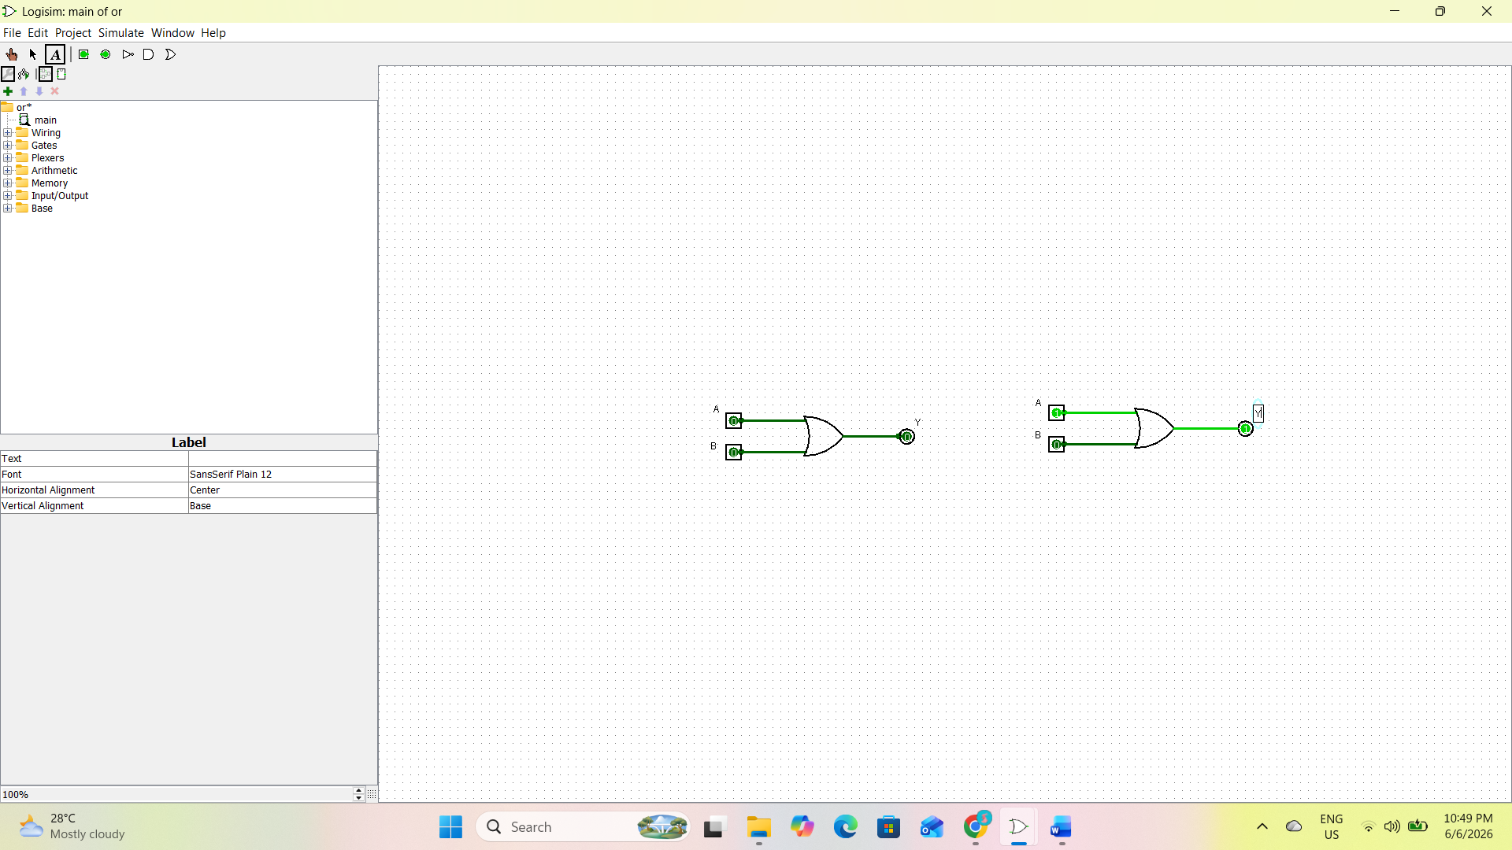

4.3 NOT Gate

Theory
The NOT gate produces the complement of the input.

Truth Table
A | Y
0 | 1
1 | 0

Simulation Result
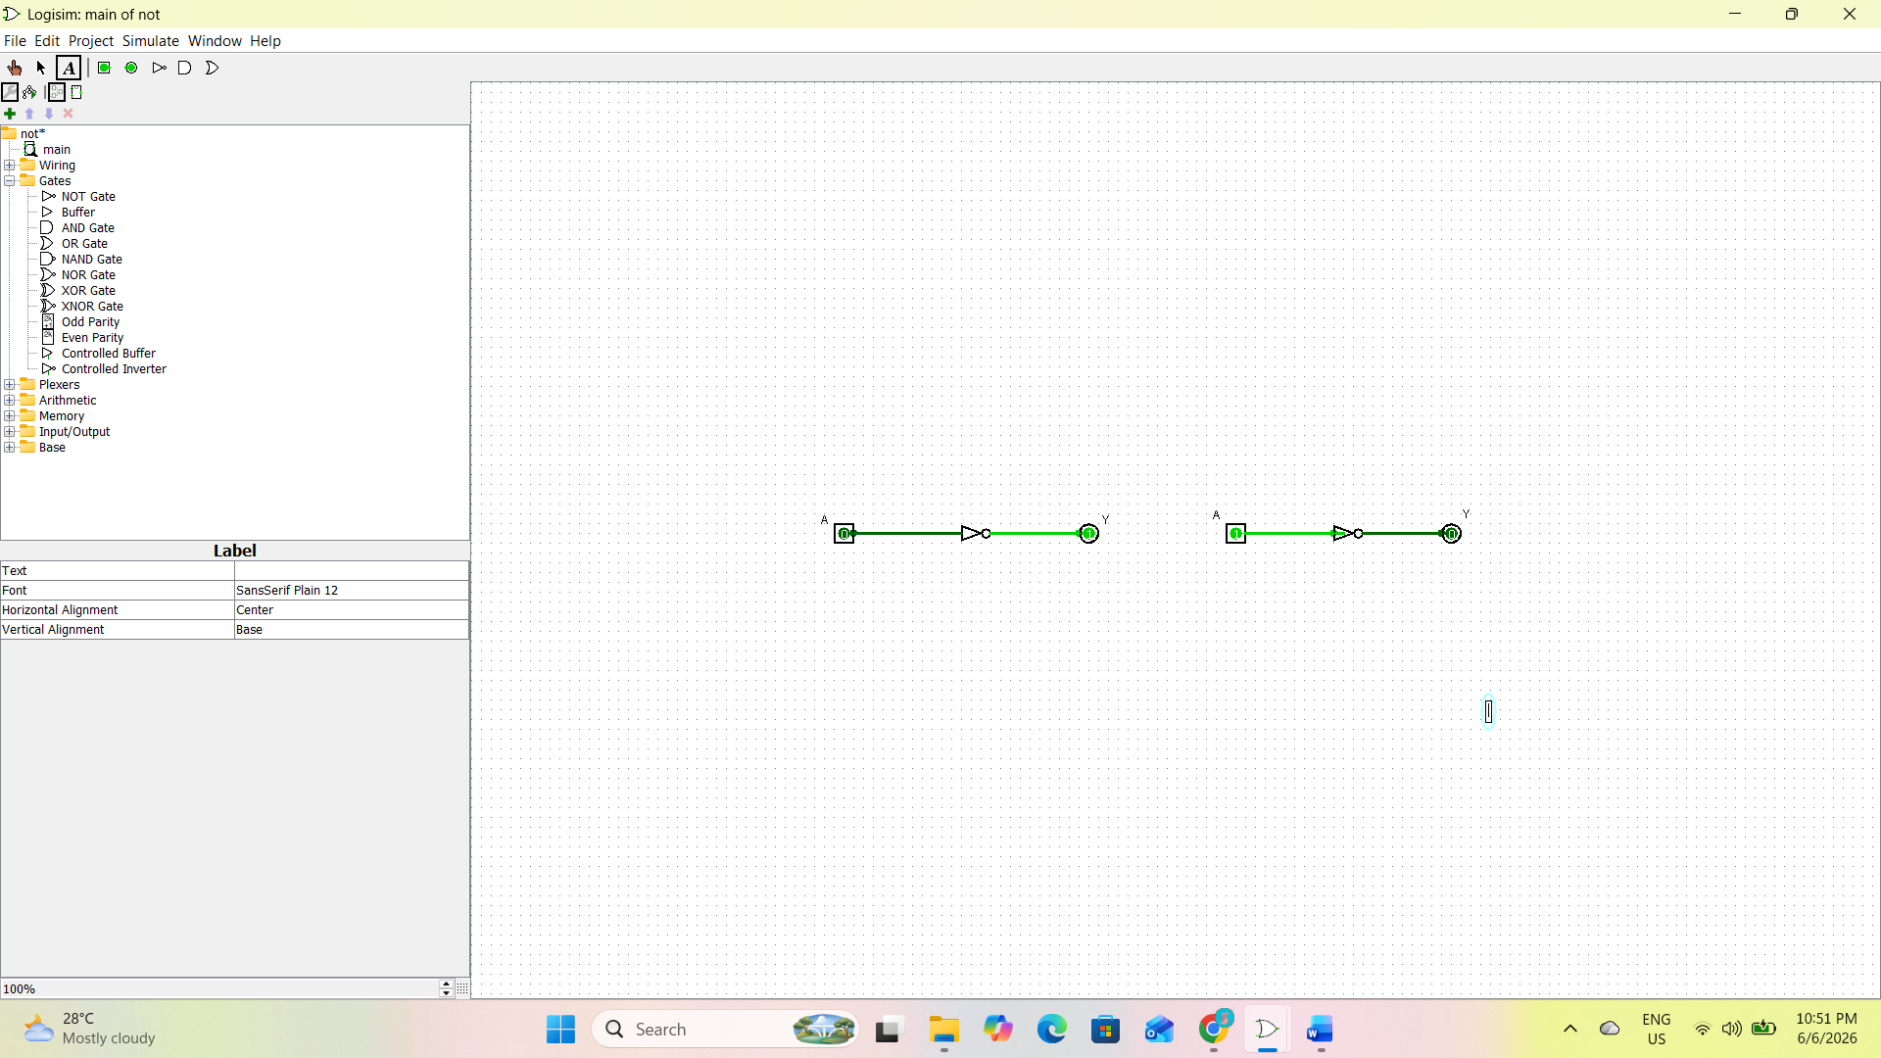

4.4 NAND Gate

Theory
The NAND gate is the complement of the AND gate.

Truth Table
A | B | Y
0 | 0 | 1
0 | 1 | 1
1 | 0 | 1
1 | 1 | 0

Simulation Result
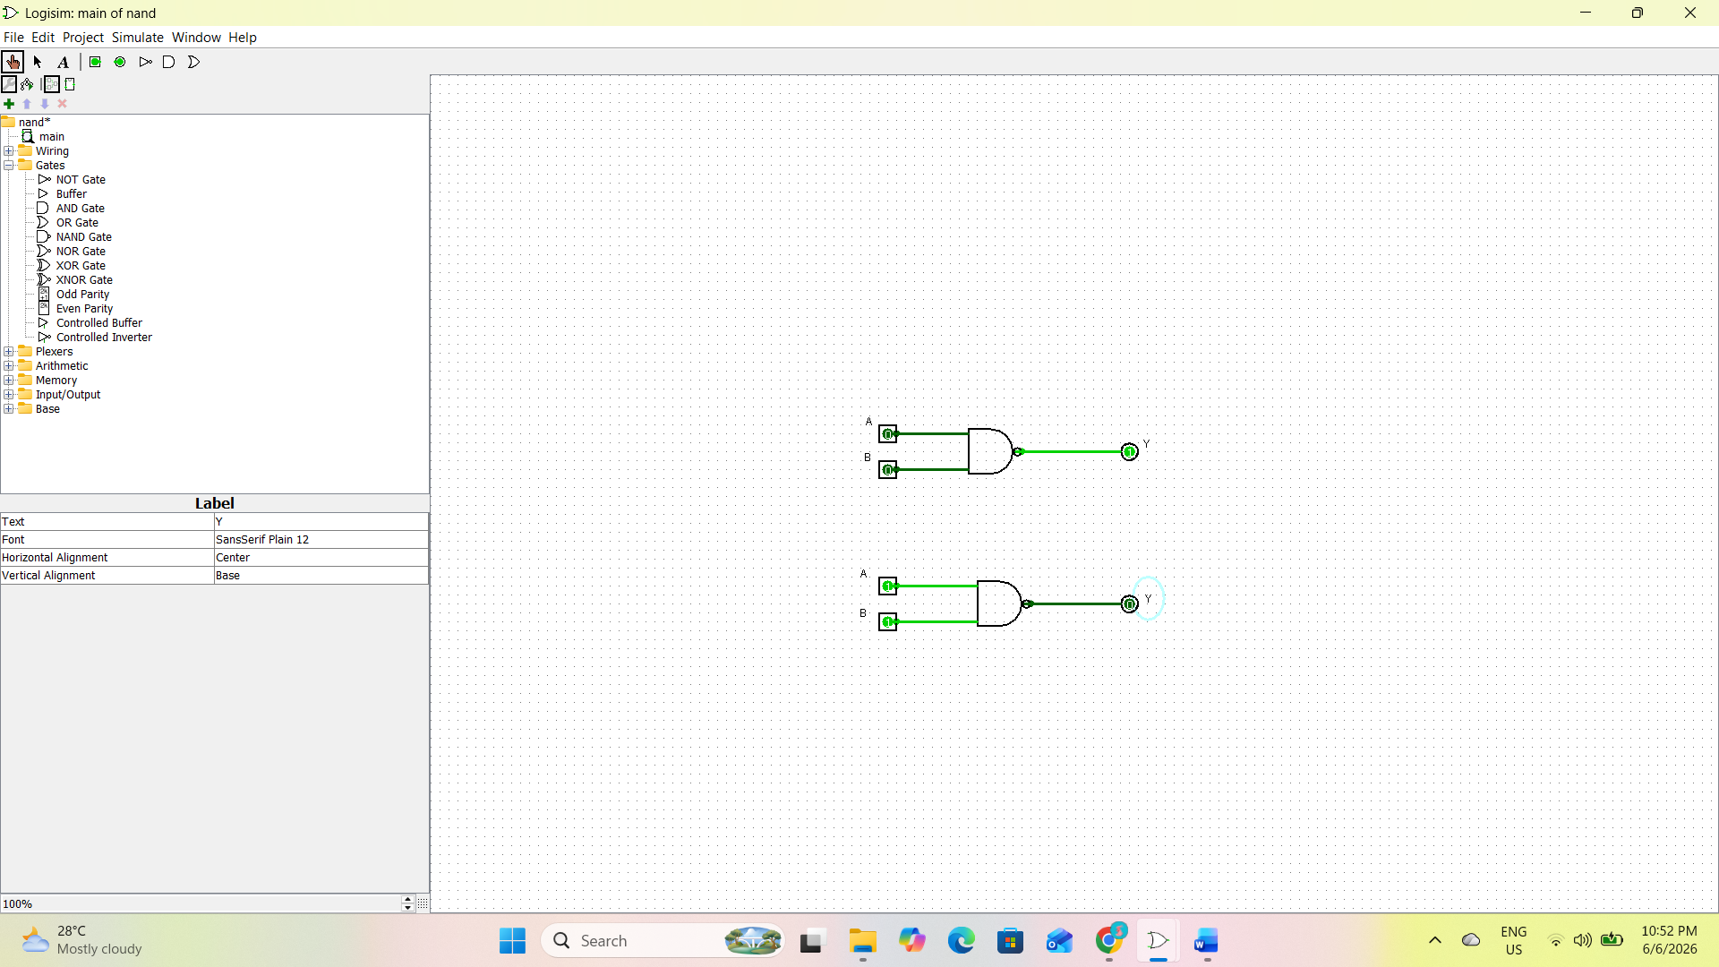

4.5 NOR Gate

Theory
The NOR gate is the complement of the OR gate.

Truth Table
A | B | Y
0 | 0 | 1
0 | 1 | 0
1 | 0 | 0
1 | 1 | 0

Simulation Result
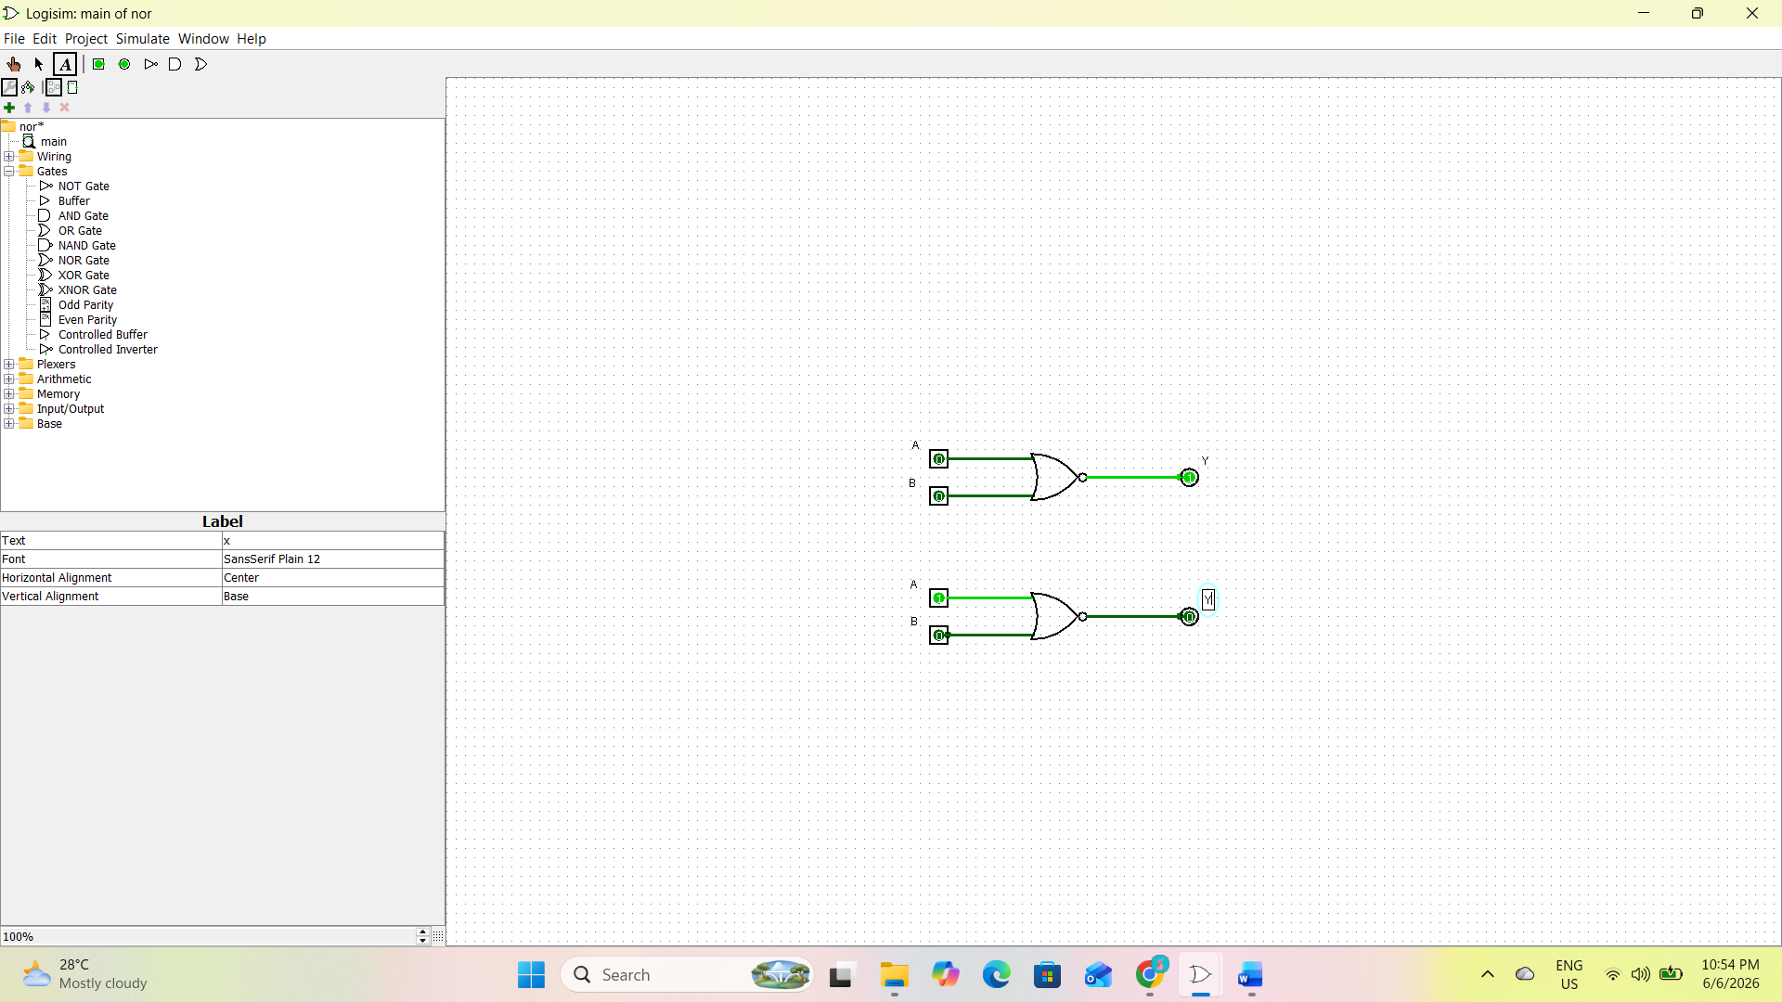

4.6 XOR Gate

Theory
The XOR gate produces a HIGH output when the inputs are different.

Truth Table
A | B | Y
0 | 0 | 0
0 | 1 | 1
1 | 0 | 1
1 | 1 | 0

Simulation Result
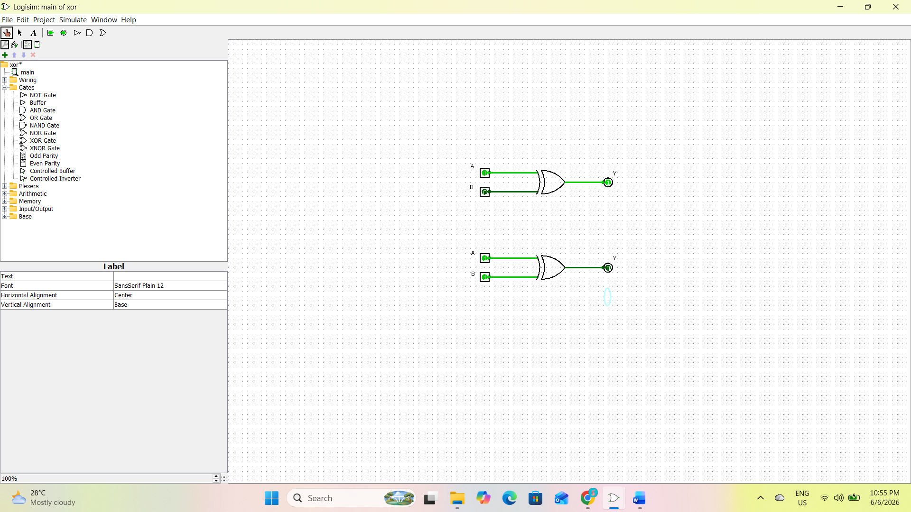

5. Implementation

5.1 Half Adder
Theory
A Half Adder is a combinational circuit that performs the addition of two single-bit binary numbers. It produces two outputs:
- Sum (S)
- Carry (C)
Logic Equations
- Sum = A ⊕ B
- Carry = A · B

Truth Table
A | B | Sum | Carry
0 | 0 | 0 | 0
0 | 1 | 1 | 0
1 | 0 | 1 | 0
1 | 1 | 0 | 1

Simulation Result
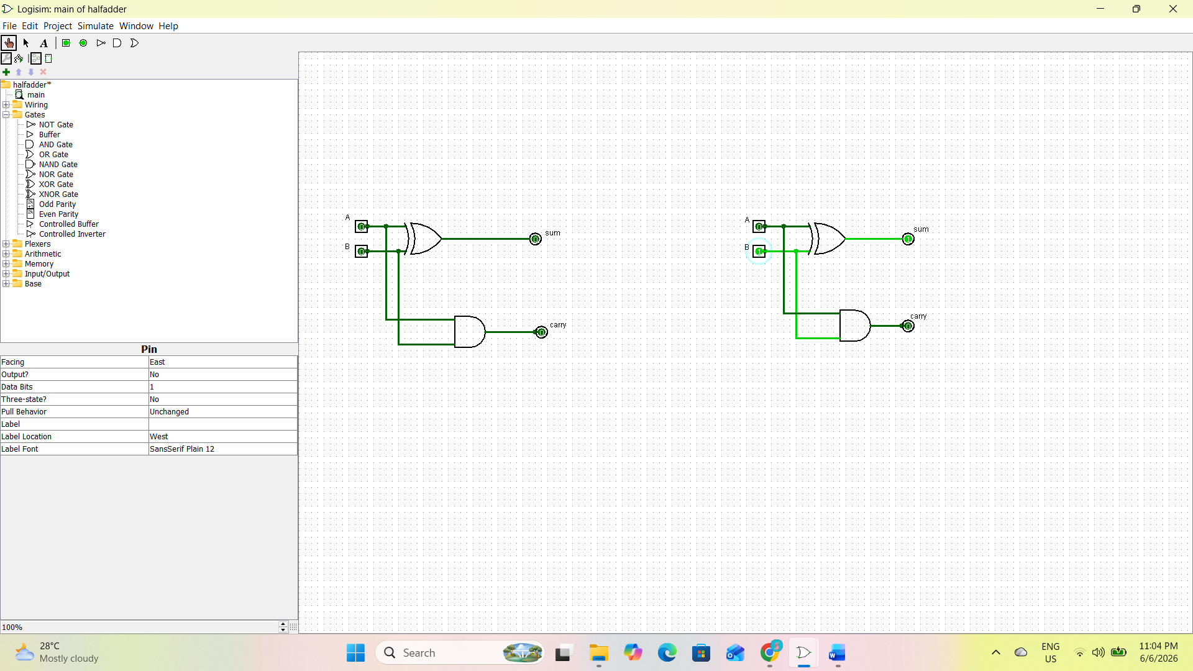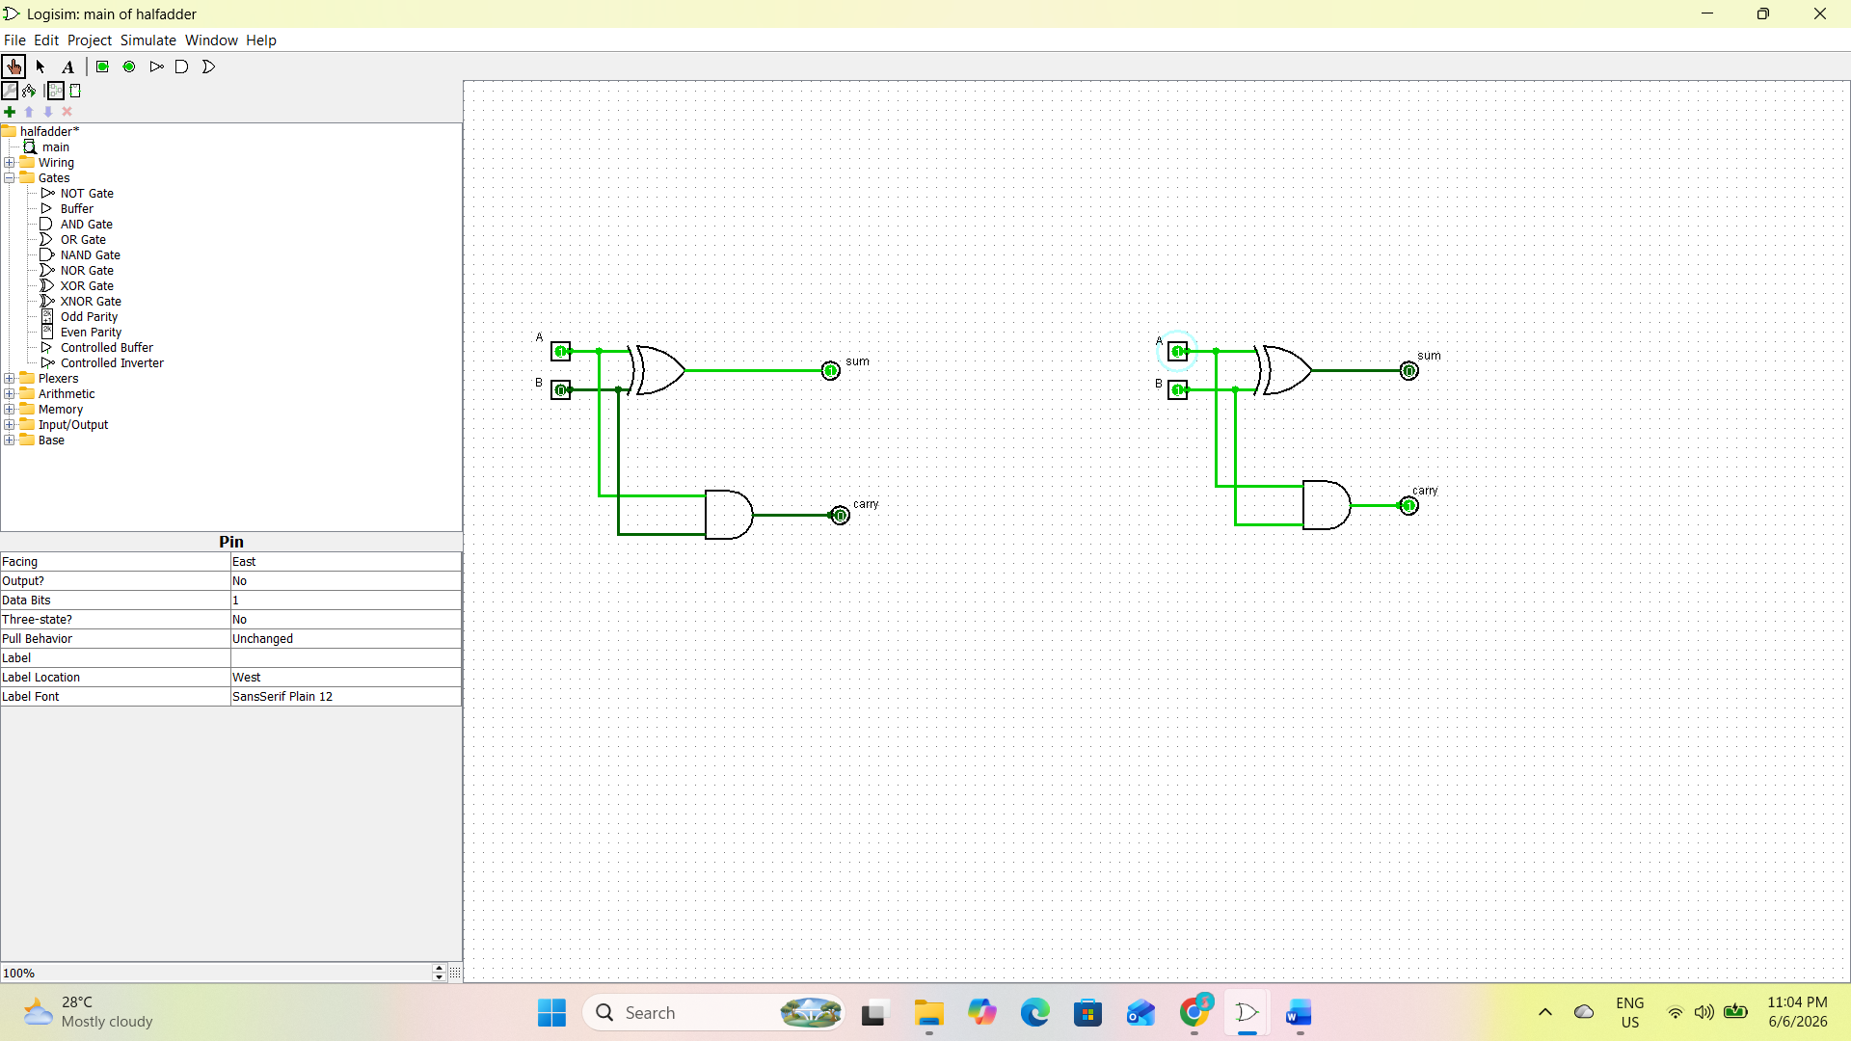

5.2 Full Adder
Theory
A Full Adder is a combinational circuit that adds three binary inputs:
- A
- B
- Carry Input (Cin)
It produces:
- Sum (S)
- Carry Output (Cout)
Logic Equations
- Sum = A ⊕ B ⊕ Cin
- Cout = AB + BCin + ACin

Truth Table
A | B | Cin | Sum | Cout
0 | 0 | 0 | 0 | 0
0 | 0 | 1 | 1 | 0
0 | 1 | 0 | 1 | 0
0 | 1 | 1 | 0 | 1
1 | 0 | 0 | 1 | 0
1 | 0 | 1 | 0 | 1
1 | 1 | 0 | 0 | 1
1 | 1 | 1 | 1 | 1

Simulation Result
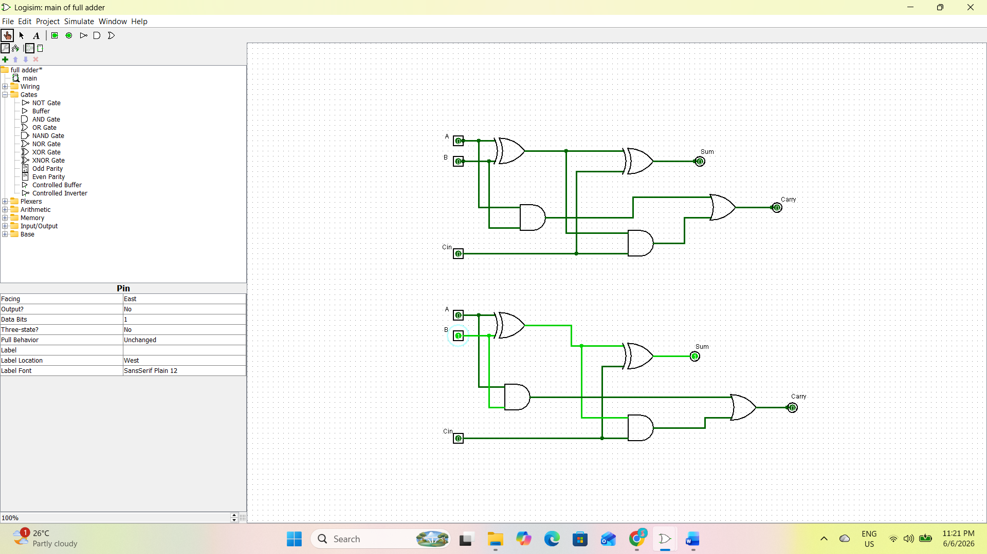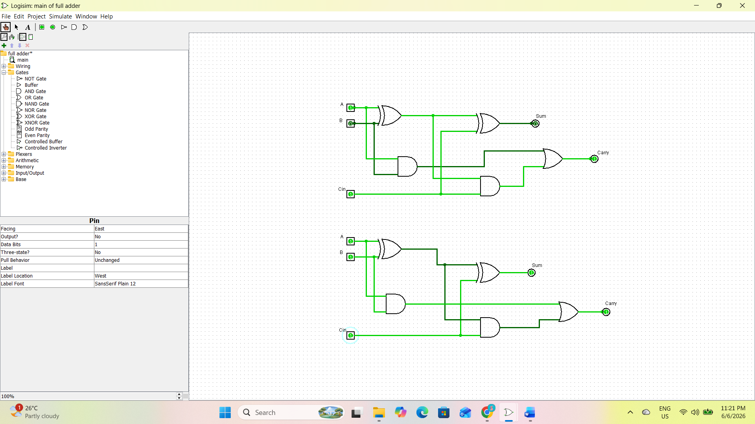

6. Observations

Basic logic gates such as AND, OR, NOT, NAND, NOR, and XOR were successfully simulated using Logisim Evolution.

The output obtained from each gate matched its corresponding truth table.

The AND gate produced a HIGH output only when all inputs were HIGH.

The OR gate produced a HIGH output when at least one input was HIGH.

The NOT gate inverted the input signal.

The NAND and NOR gates produced outputs complementary to the AND and OR gates respectively.

The XOR gate produced a HIGH output when the inputs were different.

The Half Adder successfully generated Sum and Carry outputs for all input combinations.

The Full Adder correctly generated Sum and Carry outputs for three input bits (A, B, and Cin).

The simulation demonstrated how complex arithmetic circuits can be built using basic logic gates.

7. Result

The VLSI Design Flow was studied and understood. Basic logic gates including AND, OR, NOT, NAND, NOR, and XOR were successfully designed and simulated using Logisim Evolution. The Half Adder and Full Adder circuits were also implemented and tested. The outputs obtained from all circuits matched the expected theoretical truth tables, confirming the correctness of the designs.

8. Conclusion

This task provided a fundamental understanding of the VLSI Design Flow and digital logic design principles. The simulation of basic logic gates helped in understanding Boolean operations and truth tables. The implementation of Half Adder and Full Adder circuits demonstrated how arithmetic operations are performed in digital systems. Overall, the experiment strengthened the understanding of combinational logic circuits and provided a strong foundation for further study in VLSI design and semiconductor technology.

